**Student Achievements**

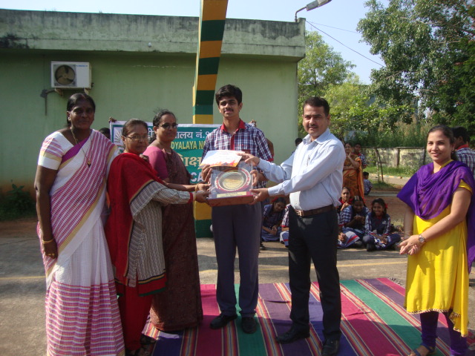

Master  Shaikh  Haroon Class XI  -   First place in the debate competition in the National Social Science Exhibition

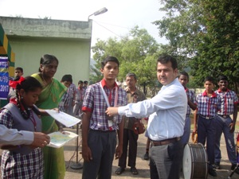

Master Parvez Maharoof

2ND POSITION IN200 M BREAST STROKE SWIMMING, 2ND POSITION IN100 M BREAST STROKE SWIMMING, 3RD POSITION IN50 M BREAST STROKE SWIMMING,( 48TH KVS NATIONAL SPORTS MEET -2017)

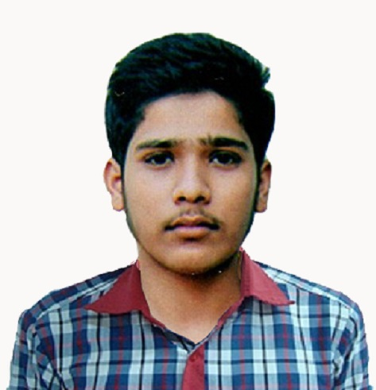

PARTH UPADHYAY

selected in NEET -2017 of class xii

**class xii students who selected in IIT**

|  |  |
| --- | --- |
| **http://www.kv1vijayawada.org/userfiles/file/001.jpg** | **http://www.kv1vijayawada.org/userfiles/file/Divyendra%20Kumar.jpg** |